**Break in nested loop java**

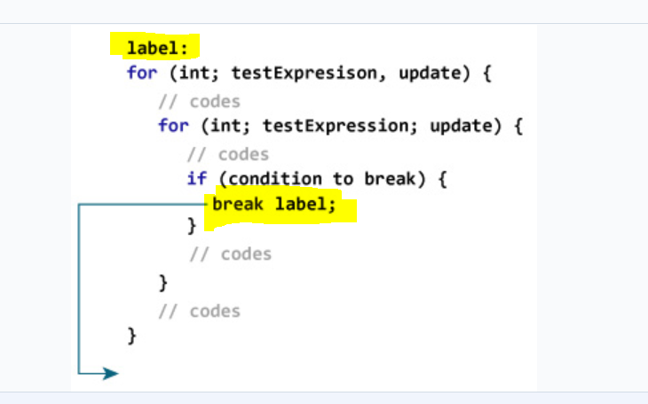

**Stack vs HEAP**

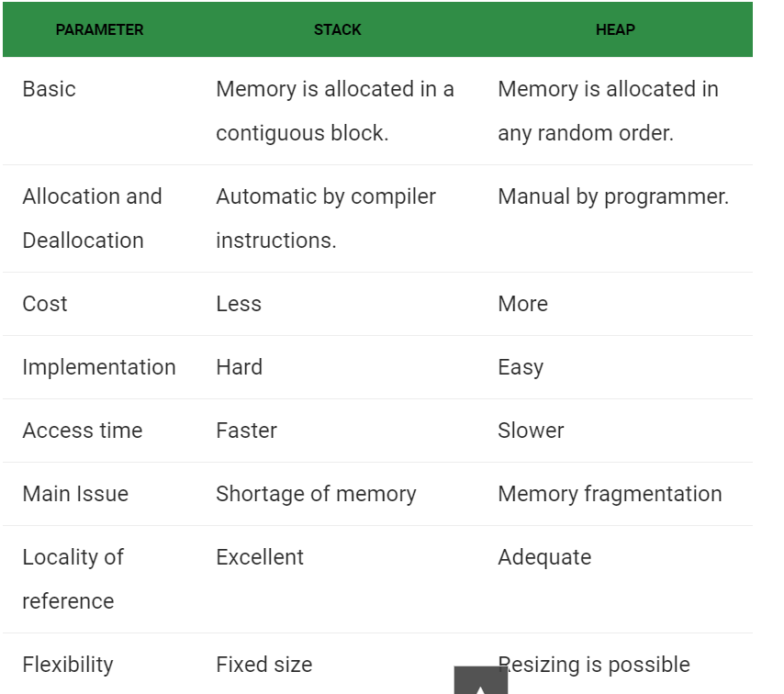

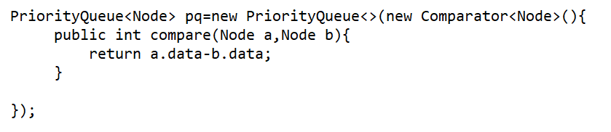

//// For string **– return a.compareTo(b); //ascending order**